**6.5.1.3 Packet Tracer – Skills Integration Challenge.**

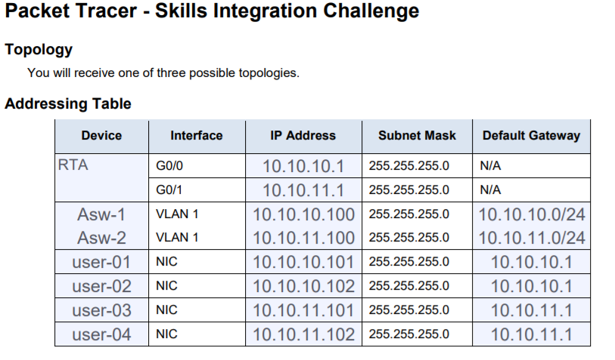

**Requirements.**

* Provide the missing information in the Addressing Table.
* Name the router **RTA** and the second switch **Asw-2**. You will not be able to access **Asw-1**.
* Use cisco as the user EXEC password for all lines.
* Use class as the privileged EXEC password.
* Encrypt all plain tekst passwords.
* Configure an appropriate banner.
* Configure addressing for all devices according tot he Addressing Table.
* Document interfaces with descpritions, including the **Asw-2** VLAN 1 interface.
* Save your configurations.
* Verify connectivity between all devices. All decives should be able to ping any other device.
* Troubleshoot and document any issues.
* Implement the solutions necessary to enable and verify full end-to-end connectivity.

**Note:** Click **Check Results** button to see your progress. Click the **Reset Activity** button to generate a new set of requirements.